Items | Plasma Platform | Plasma Pen | NeoGen Plasma
Technology | Fractional Plasma (Hot Plasma) +Plasma Pen+Cold Plasma | Plasma Pen +  Plasma Shower | Plasma
Treatment Head | 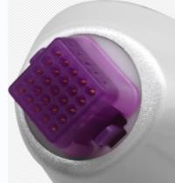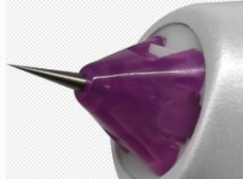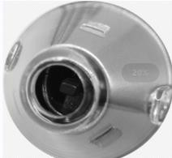 | 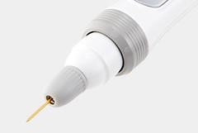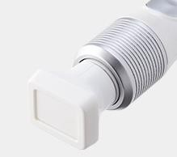 | 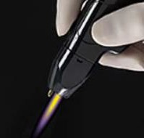
Working Principle | Fractional Plasma：In a controllable way, the needle shaped plasma column acts on the skin in the form of a dot. It’s principle is to ionize the gas in the air to generate smaller arc arches, which can act on the target tissue accurately, and heat the collagen in the dermis and in the fiber cells in the papillary layer, the thermal effect promotes the regeneration of collagen, the amount of collagen increases and is arranged in order, so as to increase the skin elasticity, tighten the skin and improve the skin condition. After treatment, the treated area serves as a repair center to promote skin regeneration and healing, thickening of dermal fibers, skin remodeling and improvement of various signs of aging and scars through the human skin wound healing mechanism.  Plasma Pen: Ionize the gas in the air to generate a smaller arc-shaped arch, which can precisely act on the target tissue, heat to cause thermal damage, stimulate the collagen in the dermis and fibro blasts in the papillary layer and the thermal effect promotes collagen regeneration.  Cold Plasma ： High-frequency voltage, electrolyzes oxygen in the air, produces ozone, kills bacteria and mites, and assists in the treatment of acne. It improves the skin’s hydrophilicity, make the oil in the sebaceous glands easier to discharge, improve the water-oil balance of the skin, penetrate the pores, and the prevent the recurrence of acne.Plasma creates dot  micro channels in tissues, expand skin keratinocyte | Plasma Pen ： Ionize the gas in the air to  produce a smaller arc arch, accurately act on the target tissue, heat to form thermal damage, stimulate the collagen in the dermis and the fibro blasts in the papillary layer and the thermal effect promotes collagen regeneration.  Plasma Shower：  High frequency voltage, electrolyzes oxygen in the air, generates ozone, kills bacteria and mites, and assists in acne  elimination. It  can improve the | The device sends millisecond pulses of nitrogen based plasma to the skin. In the hand tool, an ultra high frequency generator excites inert nitrogen gas, which is converted into active ionized gas called plasma. This plasma containing energy is guided from the tip of the hand to the skin through a quartz nozzle. The transferred energy produces a heating effect which removes the old light damaged epidermal cells on the skin surface and promotes the growth of collagen on the skin surface or beneath the dermis

 | gaps and facilitate product absorption and tissue infiltration. | skin’s hydrophilicity, make the oil in the sebaceous gland more easily discharged, improve the skin’s water oil balance, make  the pores transparent, and prevent the  recurrence of acne. Plasma can establish dot micro channels in tissues,, expand the gap between skin keratinocytes, which is  conducive to product absorption and  tissue infiltration.
Applications/Usages | *Cut moles, warts and polyp etc.  *Eyes treatment: eyelid and eye bags.  *Wrinkles: striae gravid arum, stretch mark, striae atrophicae, aging wrinkles  *Anti-aging: aged skin, flabby and flagging skin, no elasticity Scars: acne scar, surgical scar, proliferate scar, burn scar, traumatic scar.  * skin rejuvenation, pigmentation, pore shrinking, oil control and  skin cleansing, sensitive muscle improvement etc. | Acne removing, skin rejuvenation, wrinkle removing, warts cutting, eyelid lifting. | Acne, skin rejuvenation and wrinkle removal.
Analysis of  advantages and disadvantages | Advantages: The unique fractional mode makes the energy control more accurate, the operation is convenient and fast. Which reduce the hassles of operator and extremely easy to operate. Multiple energy gear are available for different treatment items. Both invasive and non-invasive with obvious anti-aging and anti-wrinkle effects. Small dots, high fineness and uniformity, short recovery period of only one week.  The cold plasma treatment head soothes the skin and  effectively improves sensitive skin, regardless of skin | Plasma Pen advantages: Cheap and convenient.  Disadvantages: single dot stab burning, large dots, manual control,  uncontrollable | Advantages: No carbonization of the epidermis, no epidermal damage.  Disadvantages: Medical nitrogen, consumables are expensive and need to be replaced frequently.  The risk factor is high and

 | type and condition. With strong energy, high ozone content, Plasma Platform has remarkable effect of removing acne, diminishing inflammation and killing bacteria.  A variety of functions with small pigment treatment and fine lines removal effect is significant. Non invasive, painless, no recovery period.  No skin color restrictions, high safety, cost-effective comprehensive platform equipment. | energy and depth, deep and heavy drilling,  uneven dots,  large skin  damage, the recovery period is generally more than half a month or even a month. The  speed of  expanding a large area is too slow. Plasma shower: The plasma shower is slightly stimulated and experience is good.  Disadvantages: weak energy,  average effects. | there are obvious burn marks in the face after treatment. The metabolic recovery period is long.  There are skin color restrictions which are not suitable for Asian people and the later pigmentation rate is high. Instruments are expensive and low cost performance.

